Correlation Between Coronary Heart Disease and Other Adverse Health Outcomes and Commuting Characteristics

**Introduction**

The effects of the built environment on health outcomes and health behaviors are becoming increasingly studied. A Pubmed search of built environment shows 481 papers published in 2000 and 7,643 published papers in 2023. The way cities are designed has a large impact on the behaviors of their citizens1. By allocating resources and building the infrastructure for active modes of transit a city can encourage physical activity in commuting.2. Encouraging physical activity is an important step in reducing the rates of coronary heart disease and obesity. Often, time constraints hinder people from participating in physical activity. However, by redesigning the built environment to promote active transportation, sedentary habits can be replaced with active ones without significantly increasing time commitments. Previous research has shown that active commuting was associated with a lower risk of cardiovascular disease (RR 0.54)3. The analysis in this paper will focus on the correlation between active commuting and heart disease at a census tract level. It is hypothesized that the percentage of persons walking to work will be inversely correlated with the percentage of persons with coronary heart disease.

**Methods**

Data on census tract-level social determinants of health was sourced from the Agency for Healthcare Research and Quality Social Determinants of Health 2020 dataset. This dataset contained information on the age distribution, income distribution, racial ethnicities, disability, and commuting characteristics of census tracts across the United States. Data for the social determinants of health dataset are sourced from the American Community Survey 5-year estimates. Health outcome data was sourced from the 2023 release of Places: Local Data for Better Health. Places is a collaboration between the Center for Disease Control and the Robert Wood Johnson Foundation. The places data uses a “multilevel regression and poststratification (MRP) approach that links geocoded health surveys and high spatial resolution population demographics and socioeconomic data.”4. The 2023 release corresponded to data from 2020 and 2021. The year 2021 data was used for this analysis as it was more complete than the 2020. Outcomes gathered from the place’s dataset include data on the percentage of adults over 18 with coronary heart disease, obesity, high blood pressure, and low physical activity levels at the census tract level. These datasets were merged and filtered to include all census tracts with populations greater than 1,000 persons over 18. The final dataset contained 45,121 unique census tracts.

All analysis was conducted in R version 4.2.0. The main predictor variable of interest was the percentage of workers who walk to work. Other commuting characteristics were analyzed, including commute time, public transit, and driving to work, but they were not included in the final regression model described later. The percentage of the adult population with coronary heart disease was the primary outcome variable analyzed. Outcomes of obesity, low physical activity, high blood pressure, and diabetes were assessed separately. All covariates were analyzed for descriptive statistics, including mean, median, min, max, first quantile, and third quantile. Density distributions of all variables were assessed visually and compared to log-transformed density distributions. Initial correlations between all predictor variables and all health outcome variables were performed. The correlation between coronary heart disease and walking to work and other commuting variables was analyzed through multi-variable linear regression. The model controlled for various demographic characteristics, including income, race, disability, education, home value, median rent, median home value, foreign-born, income inequality, and car ownership. All variables besides coronary heart disease and other outcome variables were log-transformed.

The model was evaluated for collinearity using variance inflation factor calculations. Co-linear commuting characteristic variables were removed from the model. Co-linearity was assessed but not acted on in all non-commuting-related variables. Potentially influential points were evaluated by Cook’s distance, delta betas, the influence function in R, and the Bonferroni test for outliers. Influence was also visually analyzed by plotting residuals vs Cook’s distance. Highly influential points were assessed manually for data entry errors. The linear regression model was then run without the high influence points, and the results were compared to those of the original regression model. The model's validity was assessed by visually plotting residuals vs predicted values. The normality of the residuals was assessed visually using a Q-Q plot.

**Results**

Less than 0.2% of data was missing for all variables, excluding median rent and median home value. The analysis's Census tracts from the Midwest, South, and Northeast were well represented. The West was underrepresented, likely partly due to the rural nature of large parts of the West and the exclusion of tracts of less than 1,000 persons over 18. The mean percentage of coronary heart disease was 5.93% (sd 1.76%). Mean percentages for obesity, low physical activity, high blood pressure, and diabetes were 35.23% (sd 6.67%), 25.93% (sd 7.80%), 32.93% (sd 6.83%), and 11.08% (sd 3.69%). The highest percentage age group was 18 – 44 year-olds with a mean percentage of 35.25% (sd 10.38%) followed by 45- 64 year-olds mean 26.11% (sd 5.87%). Median per-capita income was $30,668. The mean percentage of adults walking to work was 3.21% (sd 6.23%), and the median was 1.37%. The highest percentage household income group was $50,000- $99,000 with a mean percentage of 29.81% (sd 8.69%), followed closely by greater than $100,000 with a mean of 28.56% (sd 8.69%). Among education levels, a high school degree was the most common percentage, with a mean of 28.85% (sd 11.55%). Detailed information is highlighted in Table 1. Initial density plots of covariates suggested nonnormality in many variables. Since percentages are bound between zero and one hundred, variables with distributions near these extremes tended to appear non-normal. Log transformations of these variables appear to be more normal. Due to this, log transformations were performed on all predictor variables. However, non-normality was not a large concern due to the large size of the dataset. In the analysis, one data point was identified as having a data entry error. The point has a per-capita income reported that was 10 times greater than the actual value. This data was corrected before the final analysis.

Preliminary correlations between predictor variables and health outcome variables showed varying degrees of correlation. The strongest correlations with coronary heart disease among predictor variables were percent disabled (0.66), percent bachelor’s degree (-0.58), and percent high school graduate (0.57). Coronary heart disease and other outcome measures were highly correlated: obesity (0.57), low physical activity (0.64), high blood pressure (0.86), and diabetes (0.76). Complete correlation values are shown in Table 3.

A Simple linear regression model between walking to work and coronary heart disease was significant with an adjusted R- squared of 0.03284. Full results are listed in table 4. A multivariable regression predicting coronary heart disease was conducted using all other predictor variables. This model was evaluated for co-linearity using variance inflation factor analysis (VIF). VIF showed significant co-linearity among related variables such as education levels, race, income levels, and mode of transit to work. All commuting characteristics besides walking to work were dropped from the model to address the sole effect of walking to work. A high correlation among the other variables was expected; thus, all other variables were left in the model. The results of the final model are outlined in Table 5.

Cook’s distance and leverage calculations found two data points with a Cook’s distance greater than $2\sqrt{\frac{k}{n}}$ and ten data points with an influence greater than 0.3. The 0.3 influence point was determined visually from a plot of residuals vs leverage (figure 1). The regression analysis was repeated without these high-leverage data points and compared to the original model. There was no change in the adjusted r-squared (0.8125) and no change in the parameter estimate for walking to work (.00148). A Bonferroni test for outliers was found in 10 outlier data points. The results of a model without these points were compared to the model with all data points. Again, no significant difference was observed. The adjusted r-squared increased from 0.8125 to 0.8143, and the estimated walk-to-work time did not change. This does not significantly impact the analysis results; thus, the model was determined to be robust to outlier values. An analysis of the Q-Q plot (Figure 2.) for the model shows deviation from normality at the extremes but a linear trend for the central data points. The distribution of residuals appeared mostly linear (Figure 3). The lower end of estimated values does appear to slightly deviate from the linear trend.

Results for the linear regression for other outcomes were similar to those for coronary heart disease. The linear regression model predicting the percentage of obesity had an adjusted r-squared of 0.7558. The parameter estimate for walking to work was -0.0029 (p < 2*10-16). For the model predicting low physical activity, the adjusted r-squared was 0.841, and the parameter estimate for walking to work was 0.0007 (p = .0011). For high blood pressure, the adjusted r-squared was 0.7865, and the parameter estimate for walking to work was -.00411 (p < 2*10-16). For diabetes, the adjusted r-squared was 0.8212, and the parameter estimate for walking to work was -0.002636 (p < 2*10-16).

**Discussion**

The percentage of persons walking to work was found to be significantly correlated with the percentage of the population with coronary heart disease. However, the magnitude of the association was small. A parameter estimate of 0.00148 would mean a 10% increase in the percentage of persons walking to work would be associated with a 0.00148 * log(1.1) or 0.00014% increase in the percentage of the population with coronary heart disease. This is a minimal association, and the association's direction is the opposite of the analysis hypothesis. Walking to work was more strongly correlated with obesity and diabetes than with coronary heart disease. These correlations to obesity and diabetes also matched the hypothesized direction. The magnitude of the effects was also small. Based on this model, the percentage of persons walking to work is not a strong predictor of coronary heart disease, diabetes, obesity, high blood pressure, or low rates of recreational physical activity. The lack of individual-level data limited the ability of this analysis to find meaningful associations. The overall percentage of coronary heart disease is small, and the percentage of persons walking to work is even smaller. Walking to work could vigorously protect against heart disease, but the low percentage of people walking to work would make the change difficult to detect at a population level.

While the effect of walking to work was small, the model overall was very highly correlated with coronary heart disease and the other outcomes analyzed. Age distribution, income, and income inequality appear to be the most strongly correlated with coronary heart disease. This model suggests that the main drivers of adverse health outcomes in a community could be high levels of income inequality, older age distribution, low income overall, and low educational status. However, the ecologic nature of this study prevents any definitive causal relationships from being drawn. The model is also limited in its ability to predict coronary heart disease at the more extreme ends of the distribution, particularly the lower end.

The low levels of effect found in this analysis suggest future research in this area should focus on individual-level data rather than ecological data. The model also suggests that the largest impacts on heart disease could come from interventions targeted to the elderly and low-income populations.

|  |  |  |
| --- | --- | --- |
|  | Overall | Missing |
| n | 45121 |  |
| REGION (%) |  | 0 |
| Midwest | 14877 (33.0) |  |
| Northeast | 11131 (24.7) |  |
| South | 15202 (33.7) |  |
| West | 3911 ( 8.7) |  |
| ACS_AVG_HH_SIZE (mean (SD)) | 2.56 (0.44) | 0.2 |
| ACS_PCT_DISABLE (mean (SD)) | 13.73 (6.01) | 0.1 |
| ACS_PCT_FOREIGN_BORN (mean (SD)) | 11.34 (12.53) | 0 |
| ACS_PCT_AGE_0_4 (mean (SD)) | 5.92 (2.72) | 0 |
| ACS_PCT_AGE_5_9 (mean (SD)) | 5.95 (2.56) | 0 |
| ACS_PCT_AGE_10_14 (mean (SD)) | 6.25 (2.64) | 0 |
| ACS_PCT_AGE_15_17 (mean (SD)) | 3.76 (1.84) | 0 |
| ACS_PCT_AGE_0_17 (mean (SD)) | 21.88 (6.43) | 0 |
| ACS_PCT_AGE_18_29 (mean (SD)) | 16.32 (9.39) | 0 |
| ACS_PCT_AGE_18_44 (mean (SD)) | 35.25 (10.38) | 0 |
| ACS_PCT_AGE_30_44 (mean (SD)) | 18.94 (5.22) | 0 |
| ACS_PCT_AGE_45_64 (mean (SD)) | 26.11 (5.87) | 0 |
| ACS_PCT_AGE_50_64 (mean (SD)) | 19.95 (5.22) | 0 |
| ACS_PCT_AGE_ABOVE65 (mean (SD)) | 16.75 (7.12) | 0 |
| ACS_PCT_AIAN (mean (SD)) | 0.80 (4.12) | 0 |
| ACS_PCT_ASIAN (mean (SD)) | 4.11 (7.84) | 0 |
| ACS_PCT_BLACK (mean (SD)) | 14.65 (22.72) | 0 |
| ACS_PCT_BLACK_NONHISP (mean (SD)) | 14.26 (22.44) | 0 |
| ACS_PCT_HISPANIC (mean (SD)) | 13.02 (18.43) | 0 |
| ACS_PCT_NHPI (mean (SD)) | 0.14 (1.11) | 0 |
| ACS_PCT_WHITE (mean (SD)) | 72.02 (25.88) | 0 |
| ACS_PCT_OTHER_NONHISP (mean (SD)) | 0.32 (1.20) | 0 |
| ACS_GINI_INDEX (mean (SD)) | 0.42 (0.07) | 0.2 |
| ACS_PCT_HH_INC_10000 (mean (SD)) | 6.49 (6.18) | 0.2 |
| ACS_PCT_HH_INC_100000 (mean (SD)) | 28.56 (18.23) | 0.2 |
| ACS_PCT_HH_INC_14999 (mean (SD)) | 4.50 (4.18) | 0.2 |
| ACS_PCT_HH_INC_24999 (mean (SD)) | 9.16 (5.87) | 0.2 |
| ACS_PCT_HH_INC_49999 (mean (SD)) | 21.48 (8.75) | 0.2 |
| ACS_PCT_HH_INC_99999 (mean (SD)) | 29.81 (8.69) | 0.2 |
| ACS_PER_CAPITA_INC (mean (SD)) | 34455.11 (17514.77) | 0 |
| ACS_PCT_BACHELOR_DGR (mean (SD)) | 18.87 (10.39) | 0 |
| ACS_PCT_GRADUATE_DGR (mean (SD)) | 12.11 (10.52) | 0 |
| ACS_PCT_HS_GRADUATE (mean (SD)) | 28.85 (11.55) | 0 |
| ACS_PCT_LT_HS (mean (SD)) | 11.48 (9.20) | 0 |
| ACS_MEDIAN_HOME_VALUE (mean (SD)) | 245900.25 (208863.48) | 1.6 |
| ACS_MEDIAN_RENT (mean (SD)) | 1076.40 (463.48) | 2.7 |
| ACS_PCT_COMMT_15MIN (mean (SD)) | 27.79 (15.69) | 0.1 |
| ACS_PCT_COMMT_29MIN (mean (SD)) | 35.54 (12.47) | 0.1 |
| ACS_PCT_COMMT_59MIN (mean (SD)) | 27.58 (13.01) | 0.1 |
| ACS_PCT_COMMT_60MINUP (mean (SD)) | 9.09 (8.37) | 0.1 |
| ACS_PCT_DRIVE_2WORK (mean (SD)) | 88.62 (17.20) | 0.1 |
| ACS_PCT_HU_NO_VEH (mean (SD)) | 10.03 (13.39) | 0.2 |
| ACS_PCT_PUBL_TRANSIT (mean (SD)) | 6.29 (13.60) | 0.1 |
| ACS_PCT_TAXICAB_2WORK (mean (SD)) | 1.88 (2.60) | 0.1 |
| ACS_PCT_WALK_2WORK (mean (SD)) | 3.21 (6.23) | 0.1 |
| ACS_PCT_WORK_NO_CAR (mean (SD)) | 5.44 (10.96) | 0.2 |
| OBESITY (mean (SD)) | 35.23 (6.67) | 0 |
| LPA (mean (SD)) | 25.93 (7.80) | 0 |
| BPHIGH (mean (SD)) | 32.93 (6.83) | 0 |
| DIABETES (mean (SD)) | 11.08 (3.69) | 0 |
| CHD (mean (SD)) | 5.93 (1.76) | 0 |

|  |  |  |
| --- | --- | --- |
| TABLE 2. Data dictionary |  |  |
| name | label | type |
| TRACTFIPS | State-county-census tract FIPS Code (11-digit) | char |
| STATE | State name | char |
| COUNTY | County name | char |
| REGION | Census region name (South, Midwest, West, Northeast) | char |
| ACS_AVG_HH_SIZE | Average household size | num |
| ACS_PCT_DISABLE | Percentage of the population with a disability | num |
| ACS_PCT_FOREIGN_BORN | Percentage of the population that is foreign-born | num |
| ACS_PCT_AGE_0_4 | Percentage of population between ages 0-4 | num |
| ACS_PCT_AGE_5_9 | Percentage of population between ages 5-9 | num |
| ACS_PCT_AGE_10_14 | Percentage of population between ages 10-14 | num |
| ACS_PCT_AGE_15_17 | Percentage of population between ages 15-17 | num |
| ACS_PCT_AGE_0_17 | Percentage of population between ages 0-17 | num |
| ACS_PCT_AGE_18_29 | Percentage of population between ages 18-29 | num |
| ACS_PCT_AGE_18_44 | Percentage of population between ages 18-44 | num |
| ACS_PCT_AGE_30_44 | Percentage of population between ages 30-44 | num |
| ACS_PCT_AGE_45_64 | Percentage of population between ages 45-64 | num |
| ACS_PCT_AGE_50_64 | Percentage of population between ages 50-64 | num |
| ACS_PCT_AGE_ABOVE65 | Percentage of population ages 65 and over | num |
| ACS_PCT_AIAN | Percentage of population reporting American Indian and Alaska Native race alone | num |
| ACS_PCT_ASIAN | Percentage of the population reporting Asian race alone | num |
| ACS_PCT_BLACK | Percentage of the population reporting Black or African American race alone | num |
| ACS_PCT_BLACK_NONHISP | Percentage of non-Hispanic population reporting Black or African American race alone | num |
| ACS_PCT_HISPANIC | Percentage of the population reporting Hispanic ethnicity | num |
| ACS_PCT_NHPI | Percentage of population reporting Native Hawaiian and Pacific Islander race alone | num |
| ACS_PCT_OTHER_NONHISP | Percentage of non-Hispanic population reporting some other race alone | num |
| ACS_PCT_WHITE | Percentage of the population reporting White race alone | num |
| ACS_GINI_INDEX | Gini index of income inequality | num |
| ACS_PCT_HH_INC_10000 | Percentage of population with household income less than $10,000 | num |
| ACS_PCT_HH_INC_100000 | Percentage of population with household income greater than $100,000 | num |
| ACS_PCT_HH_INC_14999 | Percentage of population with household income between $10,000 and $14,999 | num |
| ACS_PCT_HH_INC_24999 | Percentage of population with household income between $15,000 and $24,999 | num |
| ACS_PCT_HH_INC_49999 | Percentage of population with household income between $25,000 and $49,999 | num |
| ACS_PCT_HH_INC_99999 | Percentage of population with household income between $50,000 and $99,999 | num |
| ACS_PER_CAPITA_INC | Per capita income (dollars, inflation-adjusted to data file year) | num |
| ACS_PCT_GRADUATE_DGR | Percentage of the population with a master's or professional school degree or doctorate (ages 25 and over) | num |
| ACS_PCT_HS_GRADUATE | Percentage of population with only high school diploma (ages 25 and over) | num |
| ACS_PCT_LT_HS | Percentage of population with less than high school education (ages 25 and over) | num |
| ACS_MEDIAN_HOME_VALUE | Median home value of owner-occupied housing units (dollars) | num |
| ACS_MEDIAN_RENT | Median gross rent (dollars) | num |
| ACS_PCT_COMMT_15MIN | Percentage of workers with < 15-minute commute time (ages 16 and over) | num |
| ACS_PCT_COMMT_29MIN | Percentage of workers with 15- to 29-minute commute time (ages 16 and over) | num |
| ACS_PCT_COMMT_59MIN | Percentage of workers with 30- to 59-minute commute time (ages 16 and over) | num |
| ACS_PCT_COMMT_60MINUP | Percentage of workers with at least 60-minute commute time (ages 16 and over) | num |
| ACS_PCT_DRIVE_2WORK | Percentage of workers taking a car, truck, or van to work (ages 16 and over) | num |
| ACS_PCT_HU_NO_VEH | Percentage of housing units with no vehicle available | num |
| ACS_PCT_PUBL_TRANSIT | Percentage of workers taking public transportation, excluding taxicab (ages 16 and over) | num |
| ACS_PCT_TAXICAB_2WORK | Percentage of workers taking taxicab, motorcycle, bicycle, or other means to work (ages 16 and over) | num |
| ACS_PCT_WALK_2WORK | Percentage of workers walking to work (ages 16 and over) | num |
| ACS_PCT_WORK_NO_CAR | Percentage of workers in households with no vehicle available (ages 16 and over) | num |
| OBESITY | percentage of adults aged 18 and older who are obese | num |
| LPA | Percentage of the population reporting no leisure-time physical activity |  |
| BPHIGH | Percentage of adults age 18 and older with high blood pressure | num |
| DIABETES | Percentage of adults age 18 and older with diabetes diagnosis | num |
| CHD | Percentage of adults age 18 and older with coronary heart disease | num |
|  |  |  |

|  |  |  |  |  |  |
| --- | --- | --- | --- | --- | --- |
| TABLE 3. CORRELATION MATRIX of social determinants of health and adverse health outcomes | Obesity | Low Physical Activity | High Blood Pressure | Diabetes | Coronary Heart Disease |
|  |  |  |  |  |  |
| AVERAGE HOUSEHOLD SIZE | 0.04 | 0.09 | -0.11 | 0.03 | -0.2 |
| PERCENT DISABLED | 0.51 | 0.54 | 0.62 | 0.58 | 0.66 |
| PERCENT FOREIGN-BORN | -0.34 | 0.04 | -0.36 | -0.08 | -0.35 |
| PERCENT AGE 0 - 4 | 0.2 | 0.22 | 0.05 | 0.16 | -0.01 |
| PERECNT AGE 5 - 9 | 0.23 | 0.19 | 0.09 | 0.16 | 0.03 |
| PERCENT AGE 10 - 14 | 0.21 | 0.16 | 0.12 | 0.15 | 0.05 |
| PERCENT AGE 15 - 20 | 0.15 | 0.08 | 0.09 | 0.09 | 0.04 |
| PERCENT AGE 0 - 17 | 0.3 | 0.26 | 0.13 | 0.22 | 0.04 |
| PERCENT AGE 18 - 29 | -0.05 | 0.04 | -0.34 | -0.16 | -0.34 |
| PERCENT AGE 18 - 44 | -0.11 | -0.01 | -0.45 | -0.24 | -0.49 |
| PERCENT AGE 30 - 44 | -0.12 | -0.1 | -0.29 | -0.18 | -0.36 |
| PERCENT AGE 45 - 64 | -0.04 | -0.16 | 0.19 | 0.01 | 0.18 |
| PERCENT AGE 50 - 64 | -0.01 | -0.12 | 0.23 | 0.05 | 0.24 |
| PERCENT AGE ABOVE 65 | -0.09 | -0.08 | 0.38 | 0.14 | 0.52 |
| PERCENT AMERICAN INDIAN OR  ALASKAN NATIVE | 0.1 | 0.07 | 0.05 | 0.1 | 0.09 |
| PERCENT ASIAN | -0.47 | -0.2 | -0.35 | -0.22 | -0.34 |
| PERCENT BLACK | 0.42 | 0.44 | 0.45 | 0.55 | 0.08 |
| PERCENT BLACK NONHISP | 0.43 | 0.43 | 0.46 | 0.55 | 0.08 |
| PERCENT HISPANIC | 0.09 | 0.33 | -0.14 | 0.19 | -0.1 |
| PERCENT NATIVE HAWAIIAN OR  PACIFIC ISLANDER | -0.05 | -0.02 | -0.05 | -0.01 | -0.04 |
| PERCENT WHITE | -0.25 | -0.42 | -0.24 | -0.47 | 0.07 |
| PERCENT OTHER NONHISP | -0.06 | 0.02 | -0.04 | 0 | -0.05 |
| GINI INDEX | 0.07 | 0.24 | 0.2 | 0.27 | 0.22 |
| PERCENT HOUSEHOLD INCOME  <10,000 | 0.44 | 0.59 | 0.37 | 0.55 | 0.32 |
| PERCENT HOUSEHOLD INCOME  > 100,000 | -0.68 | -0.74 | -0.51 | -0.62 | -0.53 |
| PERCENT HOUSEHOLD INCOME  10,000 - 14,999 | 0.43 | 0.57 | 0.4 | 0.54 | 0.41 |
| PERCENT HOUSEHOLD INCOME  15,000 -24,999 | 0.52 | 0.64 | 0.46 | 0.57 | 0.48 |
| PERCENT HOUSEHOLD INCOME  25,000 - 49,999 | 0.53 | 0.55 | 0.39 | 0.45 | 0.41 |
| PERCENT HOUSEHOLD INCOME  50,000 - 99,999 | 0.02 | -0.12 | -0.08 | -0.18 | -0.05 |
| PEr capita income | -0.64 | -0.68 | -0.41 | -0.53 | -0.39 |
| percent with BACHELOR DEGREE | -0.71 | -0.76 | -0.59 | -0.65 | -0.58 |
| percent with GRADUATE DeGRee | -0.67 | -0.66 | -0.48 | -0.54 | -0.48 |
| percent high school GRADUATE | 0.61 | 0.62 | 0.54 | 0.51 | 0.57 |
| percent less than high school | 0.49 | 0.75 | 0.34 | 0.61 | 0.33 |
| median home value | -0.68 | -0.5 | -0.49 | -0.43 | -0.46 |
| median rent | -0.61 | -0.51 | -0.5 | -0.46 | -0.55 |
| percent commute < 15 minutes | 0.2 | 0.11 | 0.1 | 0.05 | 0.24 |
| percent commute 15 - 29MINutes | 0.07 | -0.08 | 0.02 | -0.01 | -0.06 |
| percent commute 30 - 59MINutes | -0.2 | -0.09 | -0.12 | -0.08 | -0.19 |
| percent commute > 60MINutes | -0.17 | 0.05 | -0.04 | 0.05 | -0.07 |
| percent driving to work | 0.31 | -0.06 | 0.27 | 0.02 | 0.25 |
| percent of housing units with  no vehicle | 0.02 | 0.37 | 0.05 | 0.3 | 0.05 |
| percent taking public transit  to work | -0.28 | 0.07 | -0.2 | 0.03 | -0.21 |
| Other transit to work:  Taxi, bike, motorcycle | -0.07 | 0.05 | -0.09 | 0.03 | -0.09 |
| percent walking to work | -0.2 | -0.01 | -0.28 | -0.14 | -0.18 |
| percent of workers with no car | -0.09 | 0.23 | -0.08 | 0.16 | -0.08 |
| Obesity | 1 | 0.77 | 0.73 | 0.76 | 0.57 |
| Low physical activity | 0.77 | 1 | 0.68 | 0.87 | 0.64 |
| high blood pressure | 0.73 | 0.68 | 1 | 0.87 | 0.86 |
| DIABETES | 0.76 | 0.87 | 0.87 | 1 | 0.76 |
| CORONARY HEART DISEASE | 0.57 | 0.64 | 0.86 | 0.76 | 1 |

|  |  |  |  |  |
| --- | --- | --- | --- | --- |
| **Table 4. Simple linear regression: Coronary Heart Disease and Walking to Work** | | | | |
| Coefficients | Estimate | Std. Error | t value | Pr > |t| |
| Intercept | 6.0991 | 0.009166 | 665.51 | < 2*10-16 |
| Walking to work | -0.0511 | 0.001307 | -39.13 | < 2*10-16 |

|  |  |  |  |  |
| --- | --- | --- | --- | --- |
| **Table 5. Multi-Variable Linear Regression: Coronary Heary Disease and Social Determinates of Health** | | | | |
| Log(parameter) | Estimate | Std. Error | t-value | Pr > |t| |
| (Intercept) | 3.735442 | 0.066841 | 55.88581 | < 2*10-16 |
| Average Household Size | 0.085471 | 0.007373 | 11.59224 | < 2*10-16 |
| Percent Disabled | 0.051459 | 0.002254 | 22.82537 | < 2*10-16 |
| Percent Foreign Born | -0.00316 | 0.000742 | -4.25437 | 2.10E-05 |
| Percent Age 0 - 4 | 0.003903 | 0.001739 | 2.244692 | 0.024793 |
| Percent Age 5 - 9 | -8.04E-05 | 0.001729 | -0.04649 | 0.962917 |
| Percent Age 10 - 14 | -0.00091 | 0.001709 | -0.53299 | 0.594041 |
| Percent Age 15 - 20 | -0.00183 | 0.001132 | -1.62024 | 0.105189 |
| Percent Age 0 - 17 | 0.024327 | 0.005391 | 4.512258 | 6.43E-06 |
| Percent Age 18 - 29 | 0.108649 | 0.005458 | 19.90824 | < 2*10-16 |
| Percent Age 18 - 44 | -0.45364 | 0.012417 | -36.534 | < 2*10-16 |
| Percent Age 30 - 44 | 0.136824 | 0.005887 | 23.24229 | < 2*10-16 |
| Percent Age 45 - 64 | -0.05092 | 0.007639 | -6.66584 | 2.66E-11 |
| Percent Age 50 - 64 | 0.085485 | 0.006293 | 13.5847 | < 2*10-16 |
| Percent Age > 65 | 0.268655 | 0.002464 | 109.0414 | < 2*10-16 |
| Percent American Indian or Alaskan Native | -0.00074 | 0.000305 | -2.42593 | 0.015273 |
| Percent Asian | -0.00412 | 0.000347 | -11.8821 | < 2*10-16 |
| Percent Black | -0.00101 | 0.001749 | -0.57512 | 0.565214 |
| Percent Black non-Hispanic | -3.18E-05 | 0.001704 | -0.01867 | 0.985101 |
| Percent Hispanic | -0.00581 | 0.000513 | -11.3355 | < 2*10-16 |
| Percent Native Hawaiian or Pacific Islander | -0.00359 | 0.000511 | -7.01713 | 2.30E-12 |
| Percent White | 0.025008 | 0.001066 | 23.45871 | < 2*10-16 |
| Percent Other non-Hispanic | -0.00062 | 0.000352 | -1.75192 | 0.079795 |
| Gini Index | 0.203488 | 0.006681 | 30.45631 | < 2*10-16 |
| Percent Household Income  <10,000 | 0.00586 | 0.000678 | 8.643614 | < 2*10-16 |
| Percent Household Income  > 100,000 | -0.03682 | 0.001691 | -21.7753 | < 2*10-16 |
| Percent Household Income  10,000 - 14,999 | 0.004629 | 0.000507 | 9.135177 | < 2*10-16 |
| Percent Household Income  15,000 -24,999 | 0.013194 | 0.000987 | 13.37127 | < 2*10-16 |
| Percent Household Income  25,000 - 49,999 | -0.00035 | 0.002038 | -0.17161 | 0.863743 |
| Percent Household Income  50,000 - 99,999 | -0.06182 | 0.002425 | -25.4924 | < 2*10-16 |
| Per-capita Income | -0.09392 | 0.00512 | -18.3437 | < 2*10-16 |
| Percent with Bachelor’s Degree | -0.02313 | 0.00186 | -12.4307 | < 2*10-16 |
| Percent with Graduate Degree | -0.00287 | 0.001097 | -2.61397 | 0.008953 |
| Percent High School Graduate | 0.054753 | 0.002135 | 25.6469 | < 2*10-16 |
| Percentage less than high school | 0.024027 | 0.001076 | 22.33817 | < 2*10-16 |
| Median Home Value | -0.06303 | 0.001923 | -32.7732 | < 2*10-16 |
| Median Rent | -0.03985 | 0.003044 | -13.0939 | < 2*10-16 |
| Percent of Housing Units with  no Vehicle | 0.007686 | 0.000554 | 13.87621 | < 2*10-16 |
| Percent Walking to Work | 0.00148 | 0.000297 | 4.985152 | 6.22E-07 |

**Figure 2.**

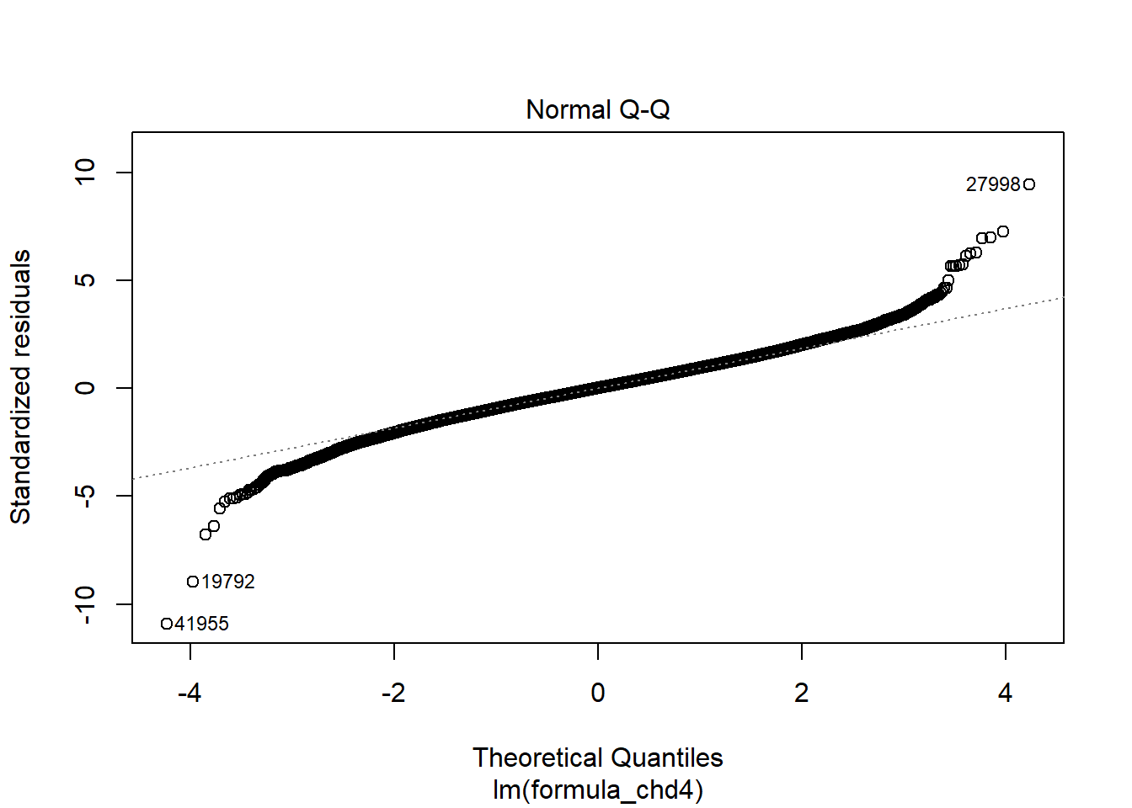

**Figure 1.**

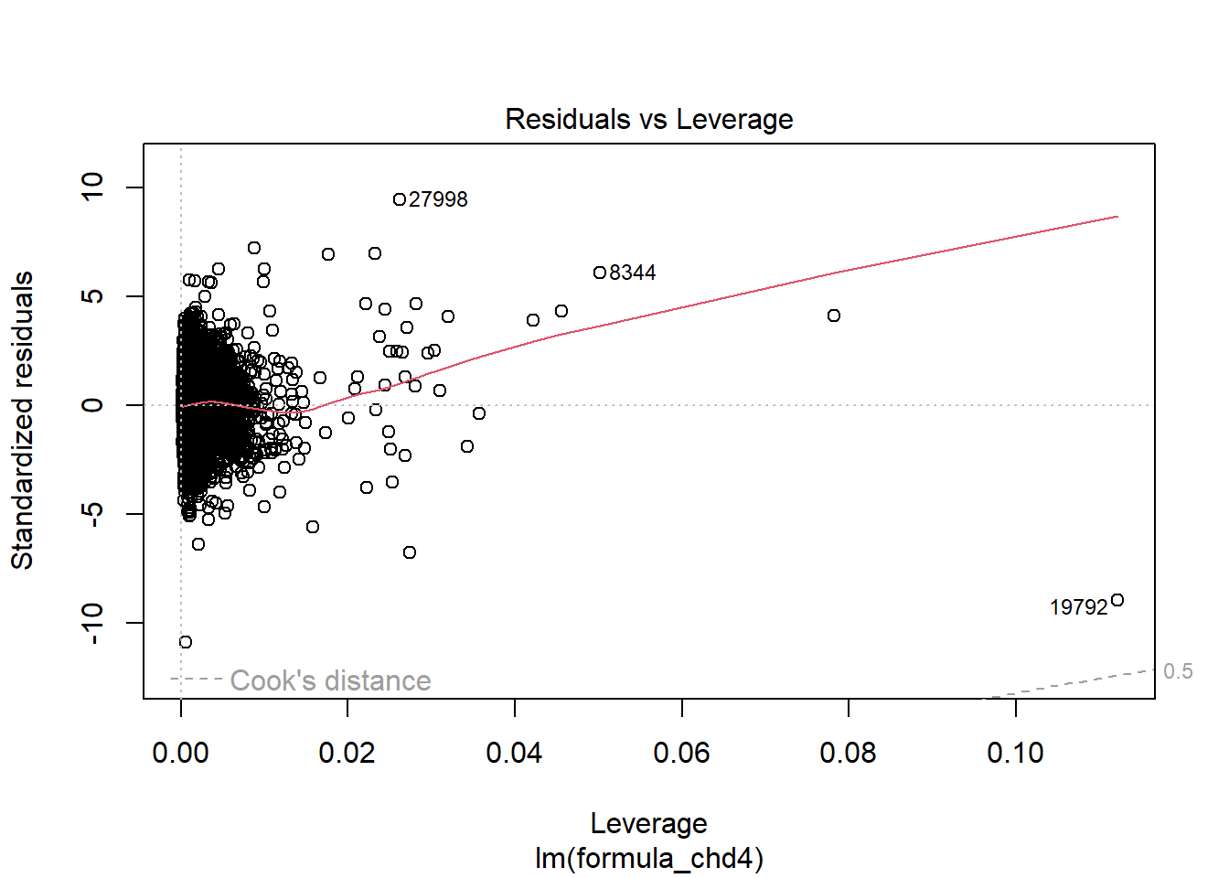

**Figure 3.**

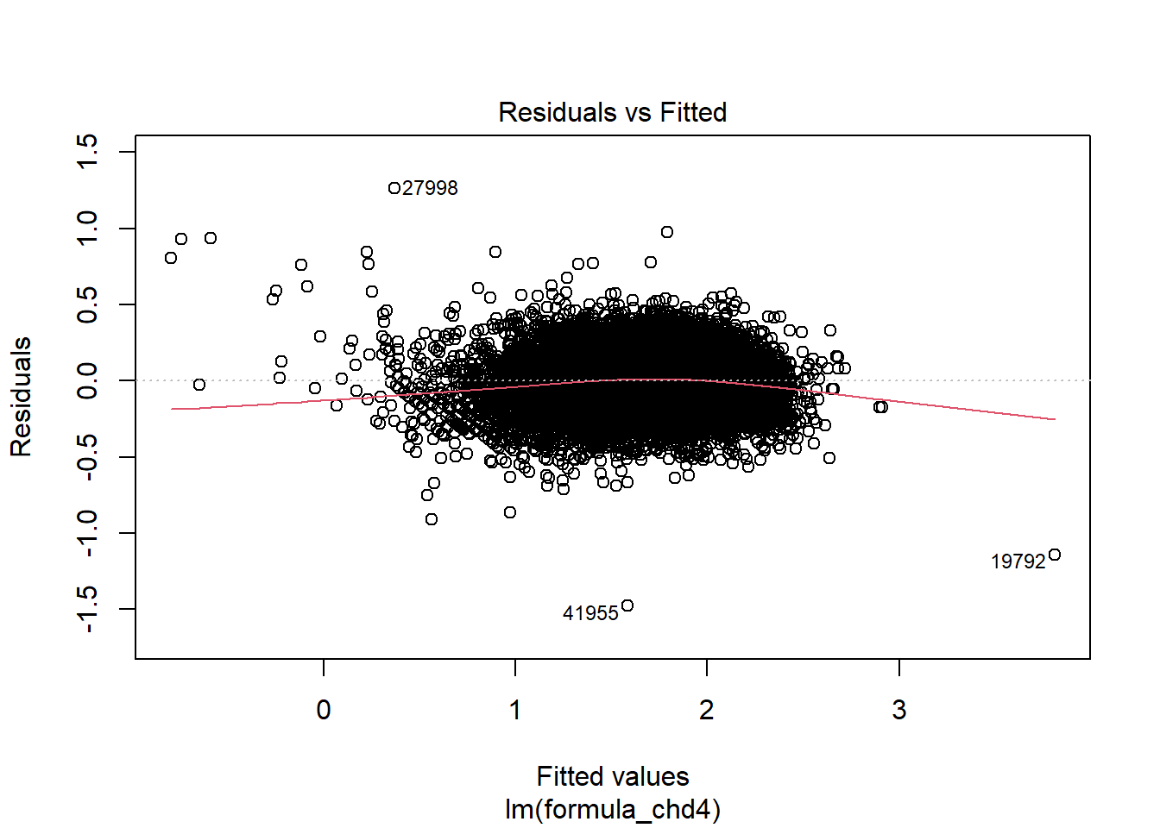

References:

1. Frehlich L, Christie CD, Ronksley PE, Turin TC, Doyle-Baker P, McCormack GR. The neighborhood built environment and health-related fitness: a narrative systematic review. *Int J Behav Nutr Phys Act*. Sep 24 2022;19(1):124. doi:10.1186/s12966-022-01359-0

2. Panter J, Heinen E, Mackett R, Ogilvie D. Impact of New Transport Infrastructure on Walking, Cycling, and Physical Activity. *Am J Prev Med*. Feb 2016;50(2):e45-53. doi:10.1016/j.amepre.2015.09.021

3. Celis-Morales CA, Lyall DM, Welsh P, et al. Association between active commuting and incident cardiovascular disease, cancer, and mortality: prospective cohort study. *BMJ*. 2017;357:j1456. doi:10.1136/bmj.j1456

4. Center for Disease Control and Prevention. Methodology, Places: Local Data for Better Health. Accessed 05/05/2024, <https://www.cdc.gov/places/methodology/index.html>